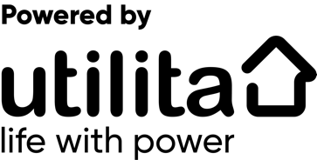
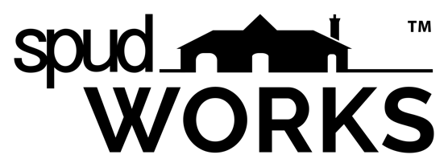

GRADUATE LAUNCH PAD APPLICATION

Please complete all sections digitally and return to mark@spud.org.uk

Name:

Address:

Email:

Phone Number:

Course Studied and Qualification:

Year of Graduation:

University:

Please explain your interest in the Graduate Launch Pad and how it may benefit you:

Please explain the nature of the work you intend to undertake if you are successful:

Please explain how you feel you may be able to contribute to the creative and collaborative environment of spudWORKS:

Do you have any special requirements or access issues? (spudWORKS is an accessible building). Please explain:

Attach up to 3 images of your work to the email no greater than 10mb combined. Please do not send separate emails. Alternatively supply a link to your own website/portfolio.

Your application should be a maximum of 1000 words

